Step: Successfully logged into the page  
Status: Pass  


Step: Successfully Navigated to Books section  
Status: Pass  


Step: Successfully Added to cart  
Status: Pass  


Step: Successfully estimated the shipping cost  
Status: Pass  
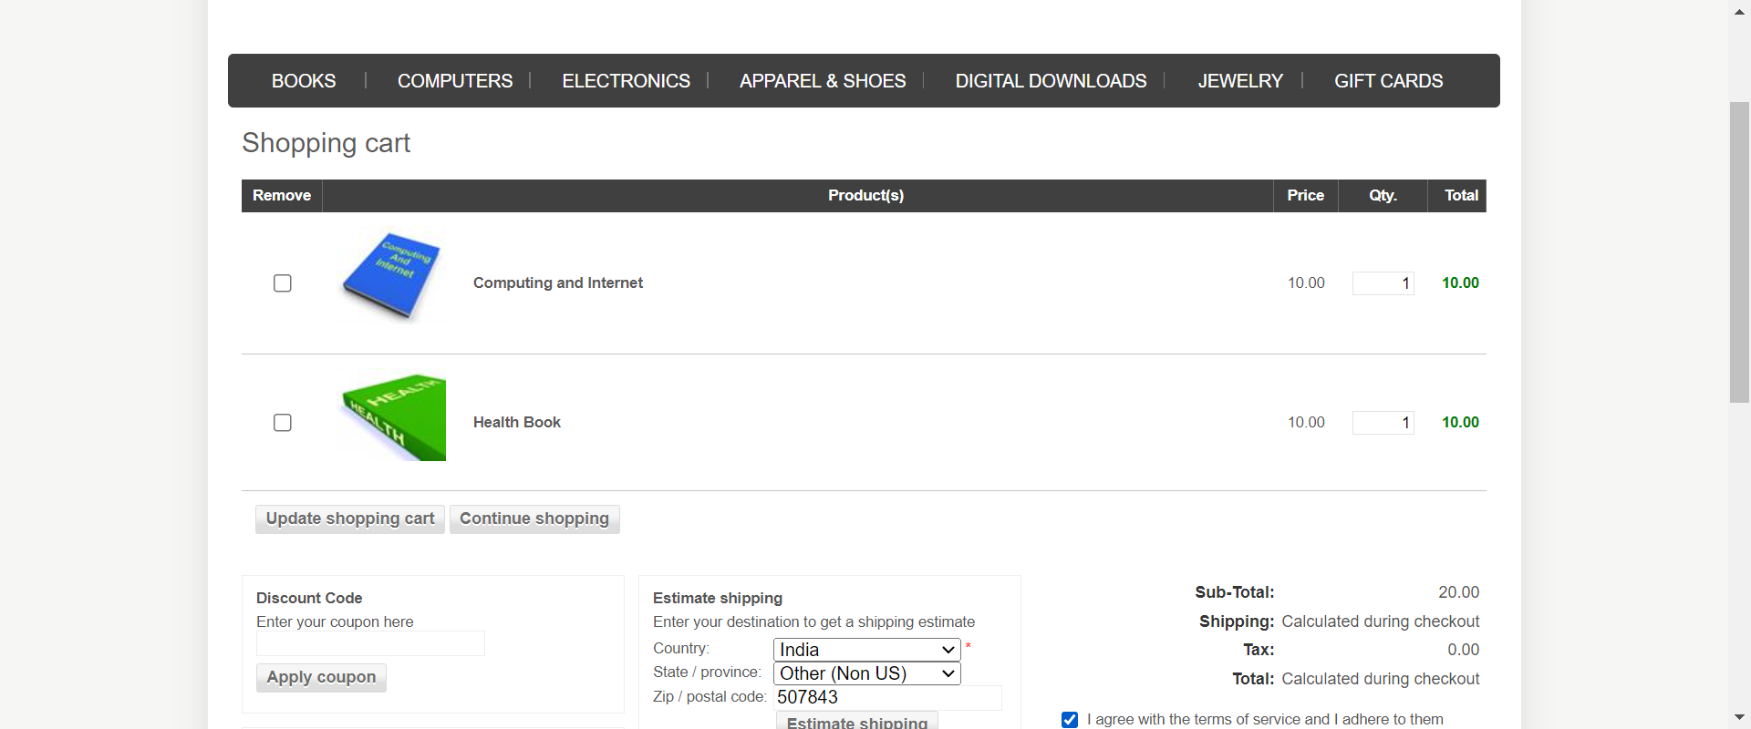

Step: Successfully got into the checkout page  
Status: Pass  
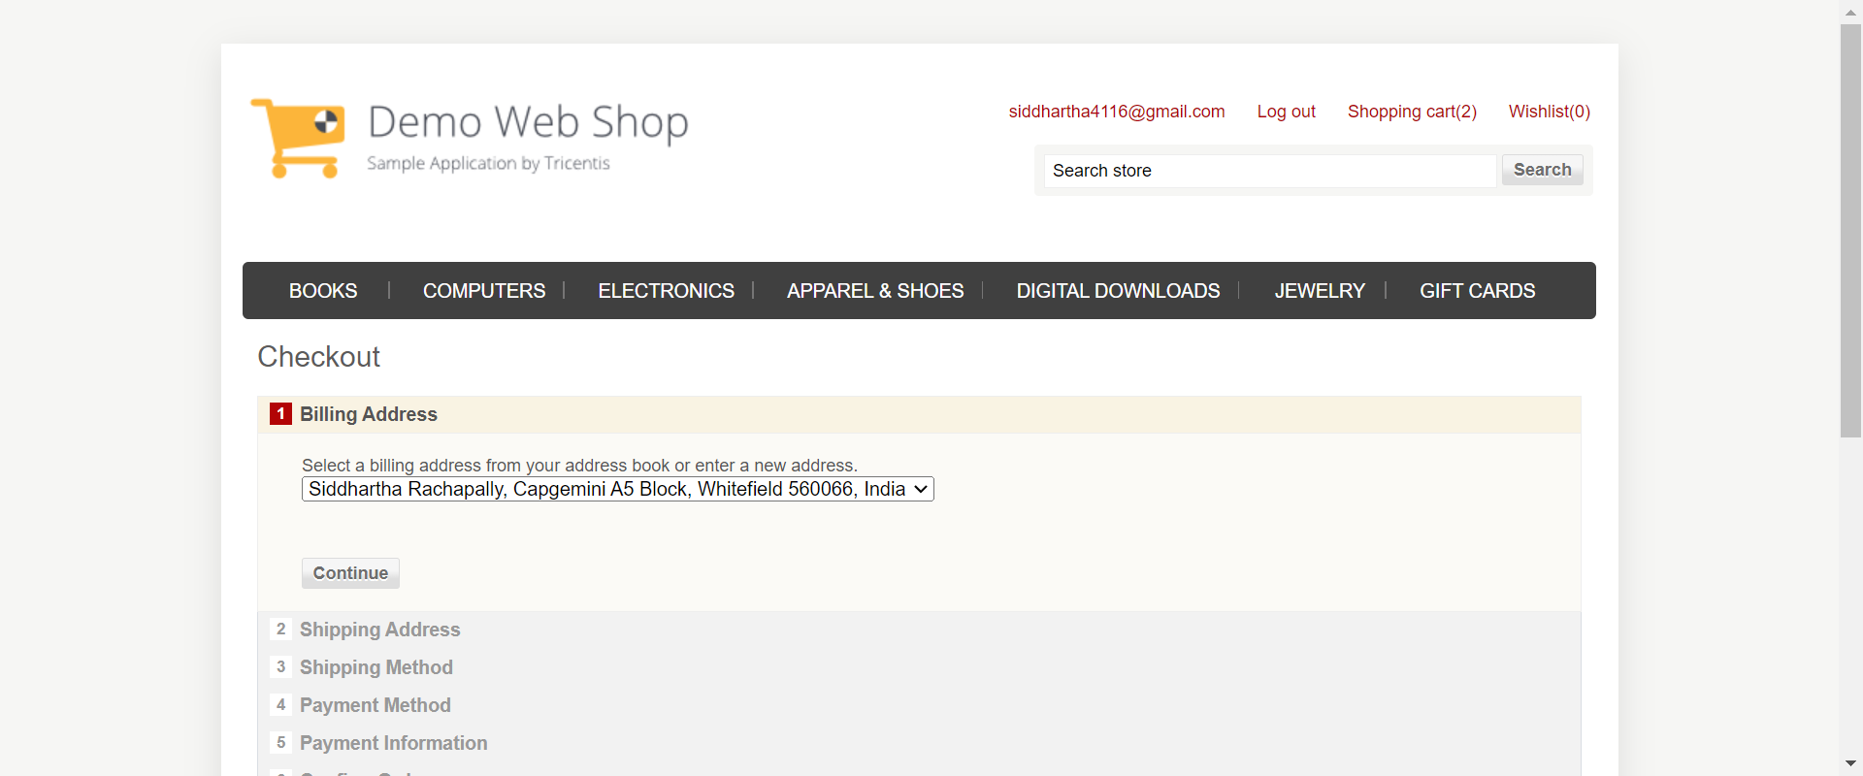

Step: Successfully placed an order  
Status: Pass  
